|  |  |  |
| --- | --- | --- |
| Uni_Logo.png |  | Zuschneiden.jpg |
| **Stiftung University of Hildesheim**  Marienburger Platz 22  31141 Hildesheim  Germany |  | **Software Systems Engineering (SSE)**  Institute for Computer Science  Faculty for Mathematics, Natural Science, Economics, and Computer Science |
|  |  |  |



**EASy Producer**

Engineering Adaptive Systems

**User Guide**

Version 0.2

07.09.2012

**Version**

|  |  |  |
| --- | --- | --- |
| 0.1 | 23.08.2012 | Initial version |
| 0.2 | 07.09.2012 | Table of content added, ??? |
|  |  |  |
|  |  |  |

Table of Contents

[1. Introduction 4](#_Toc334781646)

[2. Getting Started 5](#_Toc334781647)

[2.1. Prerequisites 5](#_Toc334781648)

[2.2. Installing EASy Producer 5](#_Toc334781649)

[2.3. Troubleshooting 5](#_Toc334781650)

[3. First Steps 6](#_Toc334781651)

[3.1. Creating a New EASy Producer Project 6](#_Toc334781652)

[3.2. Creating a Variability Model 6](#_Toc334781653)

[3.3. Creating the Variable Product Line Assets 7](#_Toc334781654)

[3.4. Defining the Instantiation 8](#_Toc334781655)

[3.5. Deriving a New Product 8](#_Toc334781656)

[3.6. Instantiating the New Product 9](#_Toc334781657)

[4. Known Bugs 11](#_Toc334781658)

# Introduction

TODO: Weitere Formatierung (Absätze, Bilder, Überschriften zu Headings machen, TOC erstellen)

Beim nächsten Update einfügen:

Die Reste aus IVML language spec, Section 5, die hier noch rein passen.

Versionierung, Strukturierung des Dokuments

Dabei: Technical Information (known bugs 🡺 see complete IVML language spec, Holger added a lot of „technical reasons“ 🡺 search for and include

Prerequisites, how to install, etc.

Bug list in external indenica repo

EASy Producer is a software product line engineering tool for the easy development of large-scale, multi-software product lines. This tool is available as an Eclipse plugin using the EASy Producer update site: <http://projects.sse.uni-hildesheim.de/easy/>

This document provides a prototypical user guide that introduces the reader to the basic capabilities of EASy and how to use them.

Please note, that this document is a living document which will evolve in accordance to the EASy Producer tool. We are working on a more exhaustive and complete user guide to ease the first steps into software product line engineering with EASy Producer.

# Getting Started

## Prerequisites

## Installing EASy Producer

## Troubleshooting

We recommend increasing the memory of your eclipse application in which you are running EASy Producer.

Open the eclipse.ini file in your eclipse directory and enter the following parameters at the end of the file:

-vmargs

-Xms40m

-Xmx512m

-XXMaxPermSize=128m

# First Steps

## Creating a New EASy Producer Project

The first step in using EASy Producer is to create a new EASy Producer Project. Open the Eclipse new wizard (by clicking on Project -> New or Ctrl + n) and select “New EASy-Producer Project” as illustrated below.

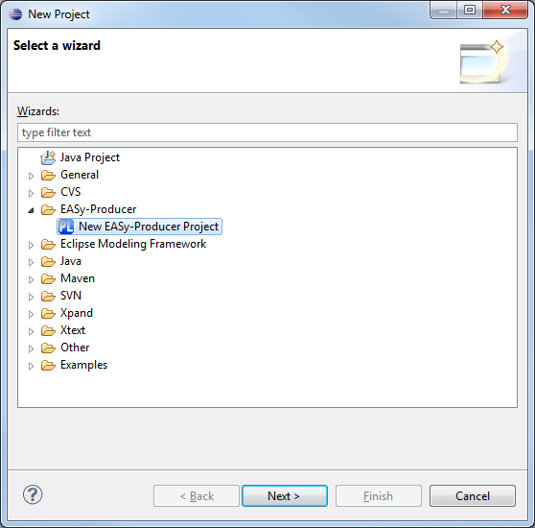

Select a name for your project and click on „Finish“, for example:

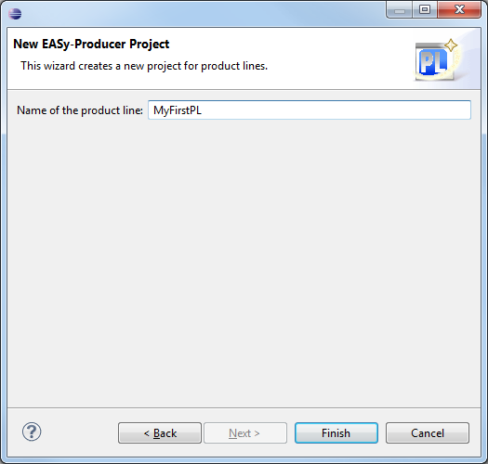

## Creating a Variability Model

The EASy Producer project created in the previous section is now displayed in the Eclipse package explorer. Open the folder “EASy” and double click the included IVML file. The name of the file is auto-generated when creating a new EASy Producer project. Please do not rename or move this file!

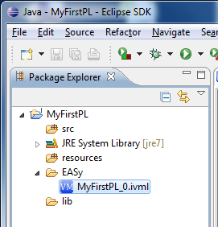

The IVML file will be open in the IVML editor. Now, you are ready to create your variability model, for example:

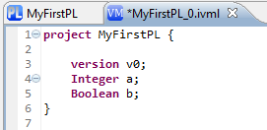

## Creating the Variable Product Line Assets

Create your product line assets inside the *src* folder using velocity syntax (c.f. <http://velocity.apache.org/>). Currently, EASy works only with java projects. Please do not make use of the default package. A simple example of how to use the velocity syntax is shown below:

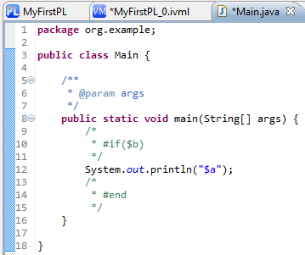

Compound variables can be accessed within velocity expression using “-“. For example:

In IVML:

compound cmp {

String str;

}

In velocity:

$cmp-str

## Defining the Instantiation

Go back to the open Product Line Configuration Editor of your current project. The editor will display the structure of your project similar to the Eclipse package explorer after switching the tabs at the bottom of the Product Line Configuration Editor.

Please switch on the “Instantiator View” tab (1.) and add “VelocityTransformatorEngine” (2.) as the instantiator of you project (3.). Further select the complete *src* folder (4.) to be instantiated by the velocity engine as illustrated below:

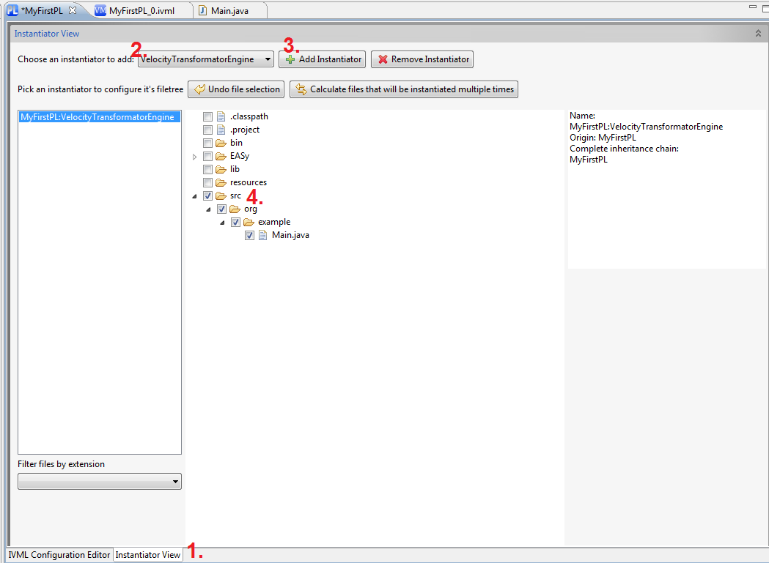

Save the editor with Control + S

## Deriving a New Product

Switch back to the “IVML Configuration Editor” tab (1.) and press the “Derive new Product Line Member” button (2.):

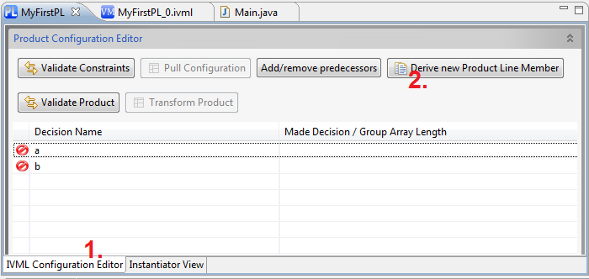

Define a new name for your product, for example, “MyFirstProduct” and press “Ok” as illustrated below:

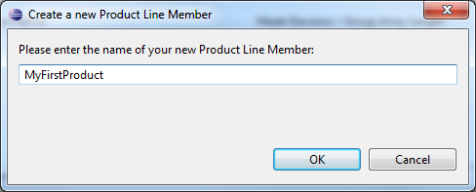

## Instantiating the New Product

Open the *<project name>/EASy/<project name>\_0.ivml* inside the newly created Product project (green arrow in the illustration below). Please do not rename or move this file. This folder contains also a copy of the product line’s IVML file, please do not modify this file as well (EASy will update this file by its own).

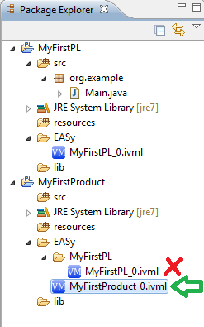

In order to configure the product and instantiate the product line artifacts accordingly, assign values to the decision variables of the IVML file of the product, like illustrated below:

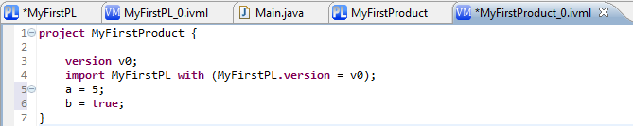

Go back to the “Product Configuration Editor” of the Product Project and switch the tabs to make the changes visible (green arrow on the illustration below).

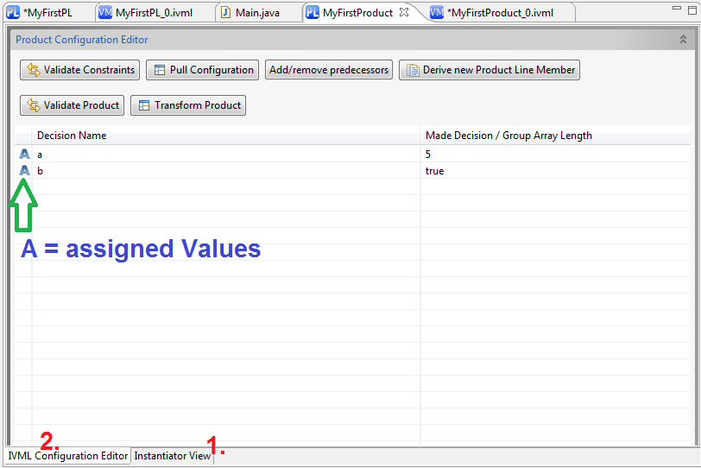

Click on “Transform Product” to instantiate the files of the product line with respect to your configuration. This will use the instantiator settings of the predecessor project (the product line project).

Finally, the product project should now contain instantiated files of the product line project (as illustrated below). Please note that the empty comments are due to the velocity markups introduced in the product line project. This will be resolved in one of the future releases of EASy.

The instantiation process will also adapt the project structure to avoid conflicts while instantiating files of a multi software product line (not tested with IVML).

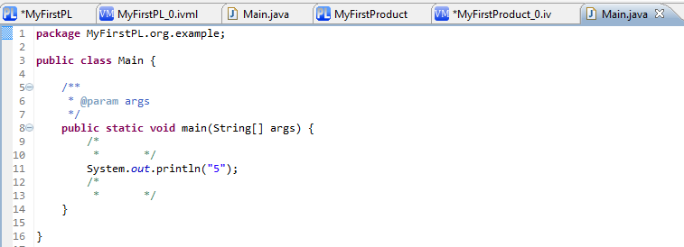

# Known Bugs

The following bugs and problems are known. We are currently working on solutions.

* Compounds will only be displayed in the configuration editor tab. However, it is currently not possible to use the configuration editor to configure compounds (use the IVML editor instead)
* In some cases, IVML elements of an imported project are marked as unknown (errors). Either restart eclipse or use the fully-qualified name to solve the errors
* The “transform” button may be disabled and, thus, product instantiation will not be possible although everything seems to be ok. In such a case, first, click on the “Pull Configurations” button and, second, switch the tabs once (from configuration editor view to instantiation view and back).
* In some situations, you may encounter performance problems or, in the worst case, freezing eclipse. If you configured the eclipse.ini file as described in Section 2.3, restart eclipse

Further bugs and their current status can be found at:

Indenica (extern)\workpackages\wp2\Easy-tasks.xlsx

Feel free to enter any problem you encounter while testing EASy. We will update this file and try to solve your problems.